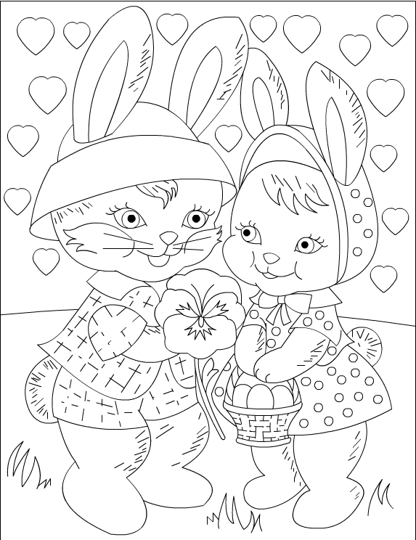

We have 3 amazing Easter Bags to give away to our lucky winners, when you enter this competition we will then put your picture in to a raffle to win one of these prizes – Best of Luck!!

To enter our Easter Colouring Competition, please fill in your details below:

Name/Account Number: ______________________________________________

Age:________________________________________________________________

School:______________________________________________________________

Parent/Guardian Name:_________________________________________________

Parent Phone Number:__________________________________________________

Closing Date of the competition is Thursday 25th March 2021 and the winners will be picked by raffle and notified by Friday 26th March 2021!
Please make sure that you drop the picture back into any of our branches to be included in the draw.
We would also love to see your picture on our Social Media, so please feel free to tag us on Facebook (Core Credit Union) or Instagram (corecu.ie) or TikTok (corecreditunion) Winning coloured sheets and names will be published also online.

